Desk Phone Detector
Computer vision threshold study
Project report for management review
Report detail | Value
Report date | 24 October 2026
Study focus | Pretrained phone detection and confidence-threshold comparison
Dataset inventory | 77 images; 74 phone boxes; 3 empty-label images
Evaluation sample | 15 images selected reproducibly from the 77-image export
Project revision | main at commit 87dc678
Current operating setting | Confidence cutoff 0.20, selected by F1 among five tested cutoffs

This report documents what was built and measured, how the evaluation was conducted, what the evidence supports, and what work is required before broader performance claims can be made.

Executive summary
The project is a desk-phone detection prototype. It uses pretrained YOLOv8s model weights to find the COCO “cell phone” class in webcam frames. The live application draws predicted boxes and plays an audio alert while at least one phone prediction is retained. The study examined whether changing the confidence cutoff could improve the balance between false alarms and missed phones.
A review of the dataset configuration found that its train, validation, and test entries all point to the same directory containing 77 images. Those directory labels do not represent independent samples. The earlier aggregate validation figures in the project README were therefore not suitable as held-out performance claims and have been removed.
A replacement evaluation selected 15 images using a deterministic random seed and evaluated a single set of pretrained predictions at five confidence cutoffs. A detection counted as correct if its box overlapped an unmatched annotated phone box at IoU >= 0.50. The best observed F1 was 0.571 at cutoff 0.20, compared with 0.519 at the 0.40 baseline. At 0.20 the counts were 8 true positives, 7 false positives, and 5 false negatives. At 0.80 precision was higher at 0.600, but recall fell to 0.231.
The result supports a limited operational recommendation: use 0.20 as the current demo setting while collecting stronger evaluation data. It does not establish an optimal threshold for other settings or production use. The 15-image subset was also used to choose the highest-F1 cutoff, so it is not an untouched final test set. The images originate from one short collection session and may contain near-duplicate views. A larger session-separated evaluation is required before claiming generalization.

Management findings
Finding | Evidence | Implication
Existing split configuration is not independent | YAML entries train, val, and test resolve to the same Dataset/train/images path. | Do not use the former validation metrics as unseen-data evidence.
The tested thresholds show a measurable trade-off | F1 peaks at 0.571 for 0.20; at 0.80 precision peaks but recall drops to 0.231. | For the current sample, the lower cutoff preserves more phone detections.
The measured sample is too small for broad claims | 15 evaluation images and 13 labeled phones; one session. | Treat values as exploratory; collect new sessions and use an untouched test set.
The live script is aligned with the observed best F1 setting | detection.py now applies conf=0.20. | Use for demonstration while monitoring false alarms; reassess with new evidence.

Recommended next decision
Retain 0.20 for a controlled demonstration, but classify it as provisional. Prioritize collection of independent, session-separated images and establish separate training, threshold-selection, and final-test groups. Do not present the present score as a production performance guarantee.

Report scope and document map
This report covers the application behavior, dataset, evaluation protocol, code changes, numeric findings, qualitative examples, risks, reproduction steps, and recommended follow-up. The report is based on the checked-in code and dataset configuration, the executed threshold sweep, and the saved visual examples. It does not claim live camera testing, model fine-tuning, or an external validation campaign.
Sections 1–3 describe the problem, system, and project changes; Sections 4–6 document the data, method, and results; Sections 7–9 cover visual evidence, implementation, and operation; Sections 10–12 assess limitations and next steps. Appendices A–E provide calculations, the algorithm, terminology, file references, and a reporting checklist.

Section 1 Problem statement and study objective

1.1 Application problem
The system is intended to recognize a smartphone on a desk from a camera view and alert the user. This is a binary application question at the user level—whether a phone is detected—even though the underlying detector produces object classes, rectangles, and confidence scores. The project also aims to reduce false alarms without losing too many real phone detections.

1.2 Study question
The implemented experiment asks: among five confidence settings (0.20, 0.40, 0.60, 0.70, and 0.80), which setting provides the highest F1 score on the selected 15-image evaluation subset, using an IoU threshold of 0.50? The primary comparison is the 0.40 baseline versus the best of the tested settings.

1.3 Scope
- Model: pretrained YOLOv8s weights, used without fine-tuning on this custom dataset.
- Target: COCO class 67, “cell phone,” treated as the phone category.
- Application: webcam display and looping audio alert on Windows.
- Evaluation: still-image object detection on a deterministic 15-image subset selected from the 77-image export.
- Improvement studied: confidence-cutoff tuning only; no augmentation, retraining, or temporal smoothing was evaluated.
The work is a small proof-of-concept study rather than a comprehensive benchmark. It establishes an auditable comparison for this project’s images and code, while identifying the additional evidence needed to support broader claims.

Section 2 System overview
The project has two paths. In the live path, each camera frame is sent to the model and detections are drawn on the displayed frame; an alarm state is updated based on whether any retained phone box is present. In the evaluation path, a list of annotated still images is passed to the model, predictions are matched to human labels, and the resulting counts are converted into metrics.
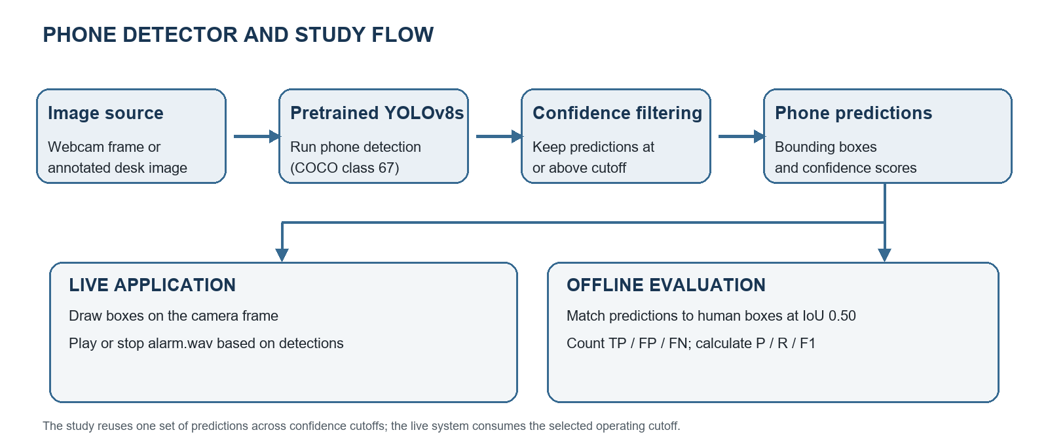
Figure 1. Application and evaluation flow. The inference model is shared; the outputs are consumed differently by the live demo and the offline study.

2.1 Live application flow
1. Load the YOLOv8s weights from yolov8s.pt.
2. Open webcam index 0 with OpenCV and read a frame.
3. Run YOLO tracking/prediction for class 67 at confidence 0.20.
4. Draw each retained bounding box and confidence label on the frame.
5. If a phone appears and the alarm is not already playing, start the WAV file asynchronously in a loop. If no phone remains and the alarm was playing, stop it.
6. Display the frame; pressing q exits and triggers normal cleanup.

2.2 Offline evaluation flow
The study loads annotations and predictions for 15 selected images. It compares boxes with an explicit overlap rule, records counts, evaluates five confidence cutoffs against the same prediction set, prints the metric table, selects the highest-F1 tested cutoff, and saves 30 visual overlays (a 0.40 baseline and a selected-cutoff overlay per image).

Section 3 Project history and study changes
The starting project contained a real-time detector, an audio asset, a pretrained model file, a dataset export, a validation script, and a threshold-sweep script. The original README reported a threshold table generated via model.val. Inspection showed the dataset YAML reused the same image directory for all named splits. This prevented those results from serving as independent validation evidence.
The study work addressed that defect by evaluating a deterministic subset directly and implementing box matching and counts. It also revised the README to document the protocol and caveats, changed the live detector cutoff to the best observed F1 setting from this subset, generated baseline/selected visual examples, and created an interview study guide. The code revision containing the core study changes is main commit 87dc678.
Change | Reason | Effect
Replace repeated model.val sweep with direct inference and matching | The configured val/test paths overlapped and did not expose per-cutoff TP/FP/FN under an explicit match rule. | Produces a fixed, reproducible subset comparison with interpretable counts.
Use seed 42 and 20% subset | Make selected images repeatable and retain a small evaluation sample. | 15 of 77 paths are selected on each run with default settings.
Define IoU matching at 0.50 | Make the meaning of a correct box explicit. | A predicted phone box receives credit only when sufficient overlap exists with an unmatched label.
Run predictions once at minimum confidence | Keep the detector output fixed across threshold conditions. | The sweep changes filtering cutoff, not the model weights or source images.
Save paired visual overlays | Allow qualitative inspection in addition to summary metrics. | 30 images are generated for the 15 selected photos.
Set live conf to 0.20 | Apply the best observed F1 setting to the demo. | Live behavior now reflects the study’s provisional operating point.

Section 4 Dataset inventory and quality

4.1 Dataset contents
The project contains a Roboflow YOLO-format export dated 3 October 2026. The single physical image folder contains 77 images; the corresponding labels folder contains 77 text files. A file-level count found 74 annotation rows across the label files and three empty label files. The nonempty rows all use class identifier 0, consistent with the one-class dataset declaration. The data.yaml names the class Smartphone.
Inventory item | Observed value | Interpretation
Images | 77 | One folder under Dataset/train/images.
Label files | 77 | One label text file per image.
Phone annotation rows | 74 | Counts label lines; not a count of distinct sessions or people.
Empty label files | 3 | Images with no phone box annotated.
Declared classes | 1 | Class name Smartphone.
Label class IDs | 0 on all 74 rows | Consistent with a single-class YOLO export.
Evaluation images | 15 | 20% of 77 rounded to 15 with the default fraction.
Labeled boxes in evaluation subset | 13 | Denominator for recall: TP + FN = 13.

4.2 Annotation representation
Each YOLO line has five whitespace-separated values: class index, normalized center x, normalized center y, normalized width, and normalized height. Normalization expresses coordinates as fractions of image width or height. For matching, the script converts the center and size representation into pixel corner coordinates: x1=(xc−w/2)×image width; y1=(yc−h/2)×image height; x2=(xc+w/2)×image width; y2=(yc+h/2)×image height. The parser ignores the class value because this export declares one target class; a multi-class dataset would require class-aware matching.

4.3 Dataset split configuration
In Dataset/data.yaml, path is Dataset, while train, val, and test are each configured to their respective images entry under train/images. Consequently all three named splits resolve to the same 77 image files. The duplicated references are a configuration defect for conventional train/validation/test reporting. The present evaluation bypasses val and test settings and reads the configured train image directory only to choose its 15-image subset.
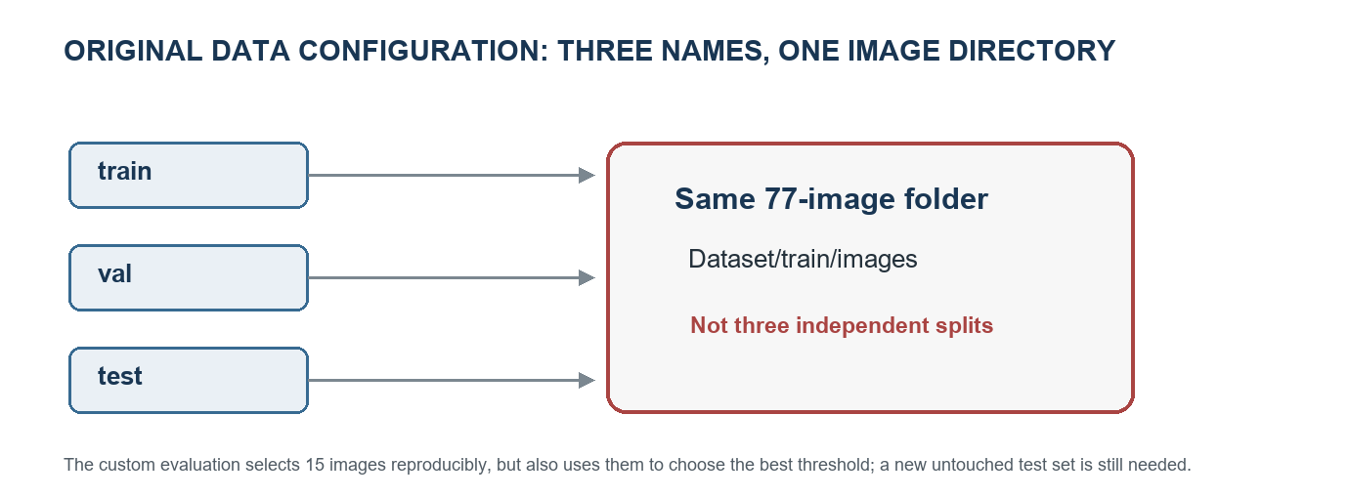
Figure 2. Why the earlier validation numbers could not be interpreted as a separate test: all three YAML names target the same directory.
A seeded random image-level subset improves repeatability, but does not remove capture-session correlation. The images were captured in one short session and may depict nearby frames or repeated views of the same desk arrangement. A stronger partition would group by session or scene, and a final test set would be collected separately.

Section 5 Evaluation methodology

5.1 Experimental setup
Parameter | Study setting
Weights | yolov8s.pt, pretrained YOLOv8s model
Inference class filter | classes=[67], COCO “cell phone”
Prediction confidence floor | 0.20, the minimum tested cutoff
Non-maximum suppression IoU setting | 0.50, passed to Ultralytics predict
Evaluation box-match IoU threshold | 0.50
Threshold values | 0.20, 0.40, 0.60, 0.70, 0.80
Subset fraction | 0.20 (default); selected size 15 of 77
Random seed | 42
Training/fine-tuning | None in this experiment

5.2 Subset selection
The script sorts image paths, copies the list, shuffles it with a local random.Random(42) generator, takes max(1, round(N×fraction)) files, and sorts the selected paths before inference. With N=77 and the default fraction 0.20, Python rounds 15.4 to 15. The selection is deterministic for this path list and seed.
This is a subset selected from the available dataset, not an untouched test set in the statistical sense. The same 15 images are used to compare the cutoffs and select the cutoff with the highest F1. Because the decision and reported score share the subset, the “best” row may be optimistic. The report uses “evaluation subset” for clarity; the script’s console message calls it “held-out,” meaning only that it is selected out of the 77 images, not that it is reserved from threshold selection.

5.3 Inference and fixed prediction set
Ultralytics predicts once on the 15 selected files with class 67, confidence floor 0.20, and NMS IoU 0.50. The script retains each predicted xyxy box and confidence score. For each tested cutoff, it filters this retained list. This design isolates the confidence filter for the sweep and avoids running a separately configured validation pass per cutoff. NMS remains fixed for all rows.

5.4 Matching rule
Within each image and cutoff, predictions above the confidence threshold are sorted in descending confidence. For each prediction, the evaluator computes IoU against every currently unmatched ground-truth box. It selects the best available overlap; if it meets 0.50, the prediction is TP and that ground-truth box is marked matched. Otherwise, the prediction is FP. After all predictions are considered, unmatched labels are FN. The code is a greedy matching algorithm: it is easy to audit and appropriate for this small one-class task, but is not a general optimal assignment solver.

5.5 Metric formulas
Metric | Formula | Interpretation for this application
Precision | TP / (TP + FP) | Among detections accepted as phones, the share that matched a labeled phone; lower precision implies more false alerts.
Recall | TP / (TP + FN) | Among labeled phones, the share found; lower recall implies more missed phones.
F1 | 2 × precision × recall / (precision + recall) | Harmonic mean used to compare the balance between precision and recall.
IoU | intersection area / union area | Geometric overlap of predicted and labeled boxes; match threshold is 0.50.

The evaluator reports zero when the relevant denominator is zero. It reports object-level precision and recall; it does not calculate image-level specificity, latency, FPS, alarm event rate, or mAP. These omitted measures should not be inferred from the current table.

Section 6 Results

6.1 Full threshold sweep
Confidence | TP | FP | FN | Precision | Recall | F1
0.20 | 8 | 7 | 5 | 0.533 | 0.615 | 0.571
0.40 baseline | 7 | 7 | 6 | 0.500 | 0.538 | 0.519
0.60 | 6 | 5 | 7 | 0.545 | 0.462 | 0.500
0.70 | 5 | 4 | 8 | 0.556 | 0.385 | 0.455
0.80 | 3 | 2 | 10 | 0.600 | 0.231 | 0.333

Across the five tested cutoffs, 0.20 yields the highest F1 (0.571). The baseline 0.40 has F1 0.519. The measured difference is +0.052 F1 points. Precision increases from 0.500 to 0.533, a +3.3 percentage-point change, and recall increases from 0.538 to 0.615, a +7.7 percentage-point change. The counts show one more TP at 0.20 while FP remains seven.
Precision is highest at 0.80 (0.600), but it is based on only five total detections (3 TP and 2 FP). Recall is 0.231: ten of thirteen labeled phones were not matched. This illustrates why selecting a threshold by precision alone would be a poor fit if the application must reliably notice phones.
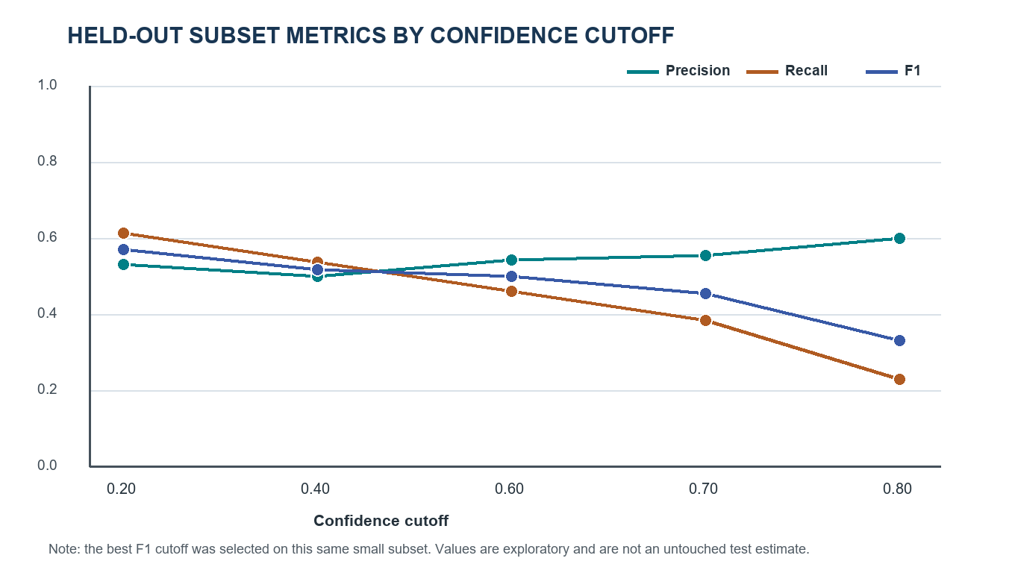
Figure 3. Precision, recall, and F1 measured at each confidence cutoff. Each point is based on the same selected 15-image subset.

6.2 Count-level interpretation
Cutoff | Predictions retained (TP+FP) | Labeled phones (TP+FN) | Plain-language reading
0.20 | 15 | 13 | 8 correct detections; 7 false alarms; 5 phones missed.
0.40 | 14 | 13 | 7 correct detections; 7 false alarms; 6 phones missed.
0.60 | 11 | 13 | Fewer false alarms than baseline; more missed phones.
0.70 | 9 | 13 | Slightly higher precision than baseline; lower recall.
0.80 | 5 | 13 | Fewest predicted boxes, but 10 phones missed.

6.3 What the experiment supports
- On these images, reducing the cutoff from 0.40 to 0.20 added one correct match without increasing the aggregate FP count.
- Increasing the cutoff progressively reduced the number of retained detections and recall; at 0.80 precision was highest but misses were frequent.
- A 0.20 cutoff is a defensible provisional setting for demonstrating this prototype when F1 is the selection rule.

6.4 What the experiment does not support
- It does not show that 0.20 is globally optimal; only five cutoffs were examined.
- It does not estimate performance on new sessions, locations, phones, cameras, or real-world negatives.
- It does not prove the live webcam alarm is reliable over time; no sequence-level measurements were collected.
- It does not compare pretrained weights with a fine-tuned model.
- It does not provide uncertainty intervals or statistical significance.

Section 7 Qualitative examples
The evaluation script saves two overlays per selected source image. One retains predictions at confidence 0.40; the other uses the best-F1 tested cutoff. The green rectangles and labels show model predictions only; they do not show the human annotation boxes. The example below is useful because the baseline displays a box on a dark rectangular desk item at score 0.41, while the 0.20 view also displays the actual phone at score 0.37. It demonstrates why a lower cutoff can recover a lower-confidence target, and why all visual judgments should be checked against the label file.
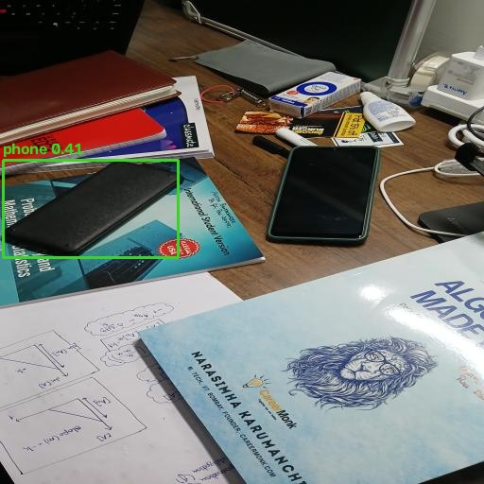  0.40 baseline | 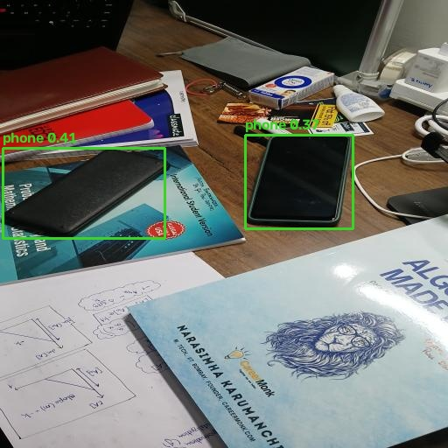  0.20 selected cutoff

Figure 4. Same evaluation image with model predictions after confidence filtering. The overlays are qualitative examples, not a substitute for aggregate metrics.

7.1 Reading this pair carefully
- At 0.40, the model retains a phone-class prediction at confidence approximately 0.41 on the dark rectangular item to the left.
- At 0.20, that prediction remains and a second, lower-confidence prediction (approximately 0.37) appears around the phone to the right.
- The pair illustrates both sides of the threshold trade-off: a lower cutoff can add a useful phone detection while preserving an earlier false detection.
- This one image does not prove why aggregate false positives stayed at seven; other images and match outcomes contribute to the dataset-level count.
The overlays are generated from predictions and do not include reference boxes. The interpretation above should be verified against the corresponding human label. For future presentation, add ground-truth boxes in a contrasting color and list each selected image’s TP/FP/FN status.

Section 8 Code and implementation detail

8.1 tunethreshold.py
Code section | Behavior | Why it exists
Constants | Sets root path, model path, seed 42, IoU 0.50, and five cutoffs. | Makes experiment settings explicit and repeatable.
dataset_paths() | Reads YAML, locates image and label directories, and lists supported image extensions. | Avoids dependence on the current terminal directory.
read_labels() | Parses each YOLO annotation line and converts normalized center-size to pixel corners. | Places ground-truth and model boxes in comparable coordinate form.
box_iou() | Calculates intersection and union areas and returns their ratio. | Implements the stated localization rule.
evaluate_at() | Filters detections by cutoff, sorts by confidence, performs one-to-one greedy matching, and counts TP/FP/FN. | Makes the cutoff comparison transparent rather than relying on an opaque aggregate alone.
main() inference | Runs model.predict once on chosen images with class 67 and confidence floor 0.20. | Creates one shared prediction set for the sweep.
Metric reporting | Calculates P/R/F1 and selects the max-F1 row. | Reports the decision rule and results.
Overlay generation | Draws retained boxes with OpenCV and writes JPEG images to Results/threshold_examples. | Supports manual review of individual examples.

8.2 Box overlap calculation
intersection = max(0, x2 - x1) * max(0, y2 - y1)
union = area_prediction + area_label - intersection
IoU = intersection / union (or 0 when union is zero)
The implementation clips negative intersection widths and heights to zero, which correctly yields zero overlap for separated boxes. It computes this for each currently unmatched annotation. Matching is performed separately per image, so a box from one image cannot match an object in another.

8.3 Detection.py
The live file opens the webcam and repeatedly calls yolo.track on a frame with class=[67] and conf=0.20. It obtains result names, converts coordinates to integers, draws a rectangle and class/confidence string, and sets phone_det=True if any detection is present. A boolean alarm tracks whether sound is already playing; this prevents the script from restarting the sound on every positive frame. When detections disappear, playback is stopped. On normal exit the sound is stopped, capture is released, and OpenCV windows are closed.
The code asks Ultralytics for tracking output but does not use track IDs to make an identity-based or temporal decision. It still makes its alert decision from whether a box appears in the current frame. The system therefore does not implement a multi-frame confirmation rule.

8.4 evaluate.py and historical figures
evaluate.py calls model.val against Dataset/data.yaml and prints Ultralytics precision, recall, and mAP50. Since the configured split paths share the same image folder, this validation route cannot be treated as a separate unseen-data evaluation. The historical README values were removed and are not reused as results in this report. The new evaluator is a custom object-level threshold sweep; it should not be confused with a full standardized detector benchmark.

Section 9 Operational behavior and requirements

9.1 Runtime dependencies and files
Requirement | Use
Python | Runs both application and evaluation scripts.
Ultralytics | Loads YOLOv8s and returns predictions.
OpenCV (cv2) | Reads webcam frames, draws boxes, reads/saves images, and displays the application window.
PyYAML | Parses Dataset/data.yaml for the custom evaluation.
NumPy / PyTorch | Typically installed as transitive/runtime dependencies of the detector stack; exact versions are not pinned in this repository.
winsound | Windows built-in sound playback used by detection.py.
yolov8s.pt | Pretrained weights required locally; excluded from Git by *.pt ignore rule.
alarm.wav | Audio file used by the live application.

The repository does not include a dependency lockfile or pinned package versions. A clean environment may therefore install versions different from the one used for the reported run. The trained weights file is ignored by Git and must be available locally before inference.

9.2 Run commands
python tunethreshold.py
python tunethreshold.py --model PATH_TO_WEIGHTS.pt --holdout 0.20
python detection.py
The evaluation prints a table and overwrites or recreates overlay files in Results/threshold_examples. The live script requires a webcam and is Windows-specific due to winsound. The evaluation was executed successfully in the local project environment; Ultralytics logged a permissions warning while attempting to save its global settings file, but the inference and report outputs completed.

9.3 Resource and runtime measurements not collected
The study does not record frames per second, inference latency, CPU/GPU utilization, memory use, camera resolution, alarm start delay, or sustained-session stability. These are material measures for a real-time deployment and should be captured in a follow-up rather than inferred from the offline image results.

Section 10 Limitations and validity assessment
Issue | Effect on interpretation | Recommended mitigation
Same folder configured as train, val, and test | Prior validation numbers are not independent. | Create explicit non-overlapping splits and validate resolved file lists.
15-image sample | One or two objects can materially change rates. | Increase the number of independent images; include more positive and negative examples.
Threshold selected on the reported subset | The best-of-five F1 is subject to selection optimism. | Use a validation subset for selection and an untouched test subset for final reporting.
Single capture session | Backgrounds/conditions are narrow and nearby frames may be correlated. | Group data by session or scene and collect separate sessions.
Pretrained model only | The study does not quantify potential gains from custom training. | Compare pretrained and fine-tuned models under the same test protocol.
Single target class | Distractors are not represented as separate learned categories. | Add representative negative contexts; review false alarms by object type.
Greedy matching | Matching is straightforward but may not maximize total overlap in complex cases. | Use an established benchmark implementation for larger multi-object evaluation.
IoU threshold fixed at 0.50 | Results may differ at stricter localization requirements. | Report mAP or repeat matching at several IoU thresholds.
No temporal benchmark | Still-image detection does not measure alert stability across video. | Measure event-level false alarms, detection delay, and flicker.
No uncertainty interval | Point estimates hide sampling uncertainty. | Collect more sessions and estimate uncertainty at image or session level.
Overlay figure lacks ground-truth boxes | Visual examples cannot alone confirm the match status. | Render labels and predictions in different colors and retain a confusion log.
No dependency pinning | Exact environment is difficult to reproduce elsewhere. | Add a requirements or lock file and document hardware/software versions.

The limitations do not invalidate the within-sample arithmetic. They restrict the population and operational claims that can be made from it. The result is useful as a baseline for the next study, provided it is presented with its sample size and selection procedure.

Section 11 Recommendations and next steps

Priority 1 create an independent evaluation design
1. Capture new phone-present and phone-absent images across separate sessions, rooms, angles, lighting conditions, device models, and realistic desk clutter.
2. Group data by capture session or physical setup so related frames remain together in one partition.
3. Create distinct training, threshold-selection, and final test partitions; verify that the file lists do not overlap.
4. Keep the final test set untouched until model and threshold decisions are complete.

Priority 2 improve error evidence
1. Audit a sample of the labels for box tightness, missed phones, ambiguous views, and consistency.
2. Store per-image results including source image, ground-truth count, predictions, IoU matches, and TP/FP/FN status.
3. Review false alarms by distractor category, such as power bank, wallet, calculator, or dark rectangular object.
4. Generate side-by-side figures that show both human labels and model predictions, using distinct colors and legends.

Priority 3 assess model and application improvements
1. Compare pretrained YOLOv8s with a fine-tuned version using the same data partitions and fixed final test set.
2. Report precision-recall curves or mAP alongside threshold-specific metrics.
3. Test temporal confirmation (for example, detections in several of the last few frames) to reduce one-frame alert flicker.
4. Measure latency, frame rate, time to first detection, alarm event count, and sustained camera behavior.
5. Choose the operating point according to the actual cost of missed phones versus nuisance alarms.

Priority 4 improve operational reproducibility
1. Pin Python package versions, document the operating system and device, and specify model weight provenance.
2. Use robust path resolution for model and audio files in detection.py.
3. Wrap camera and audio cleanup in a finally block so exceptions also release hardware resources and stop the alarm.
4. Add command-line parameters for camera index and confidence cutoff if the demo will be reused.

Section 12 Conclusion
The project provides an end-to-end prototype: pretrained phone detection, webcam visualization, and an audio alert. The study improves the evidence around that prototype by defining box correctness, counting matched and unmatched objects, and comparing five confidence settings on a reproducible subset. The present data favors confidence 0.20 by F1 (0.571) over the 0.40 baseline (0.519) for the specific 15-image evaluation subset.
The correct management interpretation is provisional. The same subset selects and reports the threshold, the sample is small, and all images originate from one session. The old train/validation/test configuration was not independent. The current live cutoff is therefore suitable as a demonstration setting, while a broader deployment decision should wait for session-separated data, threshold selection on validation data, and a final evaluation on an untouched test set.

Appendix A Metric definitions and worked example
For cutoff 0.20, the evaluator counts TP=8, FP=7, and FN=5. There are 15 retained predictions and 13 labeled phones in the selected images.
Precision = TP / (TP + FP) = 8 / (8 + 7) = 0.533
Recall = TP / (TP + FN) = 8 / (8 + 5) = 0.615
F1 = 2 × 0.533 × 0.615 / (0.533 + 0.615) ≈ 0.571
At the 0.40 baseline, TP=7, FP=7, and FN=6. Precision is 7/14=0.500; recall is 7/13=0.538; F1 is approximately 0.519. The derived F1 difference is approximately +0.052 absolute. These formulas operate on object counts, not on the number of images.

Appendix B Evaluation algorithm in plain language
1. Read the selected image’s ground-truth phone boxes.
2. Keep model boxes whose confidence is at least the cutoff currently being evaluated.
3. Sort those boxes from most confident to least confident.
4. For each prediction, find the still-unclaimed annotation with the largest IoU.
5. If the best overlap is at least 0.50, count a TP and claim that annotation; otherwise count an FP.
6. After processing predictions, count each unclaimed annotation as an FN.
7. Repeat for each selected image, sum counts across the evaluation subset, and calculate precision, recall, and F1.
The matching is performed independently per image. A predicted object cannot match an annotation in another image. An empty label file contributes no ground-truth phones; any retained phone prediction on such an image would count as a false positive.

Appendix C Important terminology
Term | Definition used in this report
Object detector | A model that predicts an object category and a location box.
Pretrained model | A model whose weights were learned before this project; these weights were not fine-tuned on this desk dataset.
Inference | Running a trained model to get predictions for an image.
Confidence cutoff | Minimum score required for keeping a prediction.
Ground truth | Human-provided label treated as the reference answer.
IoU | Intersection over union; a ratio from 0 to 1 that measures overlap between two boxes.
TP / FP / FN | True positive, false positive, and false negative object counts.
NMS | Non-maximum suppression, a detector post-processing step that removes overlapping candidate boxes; inference IoU is kept fixed in this sweep.
Evaluation subset | The seeded 15-image sample on which all cutoff results were calculated and the preferred cutoff selected.
Untouched test set | Data not used to train, tune, or select the reported model or threshold; the current study does not have such a set.
Data leakage | Overlap or close relationship between data partitions that can make performance appear more general than it is.

Appendix D Project file reference
Path | Role in the study
detection.py | Live webcam inference, drawing, and audio alert; current confidence cutoff is 0.20.
tunethreshold.py | Seeded subset selection, inference, IoU matching, metrics, and overlay output.
evaluate.py | Earlier validation script; relies on the overlapping YAML split configuration.
Dataset/data.yaml | Declares dataset root, train/val/test paths, and Smartphone class.
Dataset/train/images/ | 77 source desk images.
Dataset/train/labels/ | 77 corresponding YOLO annotation files.
yolov8s.pt | Local pretrained model file, excluded from Git.
alarm.wav | Audio alert used by the live application.
README.md | Concise protocol, result, run instructions, and limitations.
Results/threshold_examples/ | 15 pairs of threshold-filtered prediction overlays.

Appendix E Result interpretation checklist
- Always state the evaluation sample size (15 images) next to the metrics.
- State that the subset is used to select the best cutoff; do not call it an untouched test result.
- State the IoU rule (0.50) and that matching is one-to-one and greedy.
- Distinguish the score trade-off: 0.20 has the best F1; 0.80 has the best precision and much lower recall.
- Do not use the historical README metrics as independent validation performance.
- Do not imply custom fine-tuning, data augmentation, or real-time sequence evaluation occurred.
- Describe 0.20 as the best among the tested settings on this subset, not a universal optimum.
- Pair any visual overlay with its human annotation when asserting a detection was correct.

